Phase 1 Project Dataset Summary
Team: Mohammed Ali Shakeel Ashtikar – 202621080 | Syed Mohammed Ali Javed - 202604540 | Mohammad Huzeifa - 202621060
We selected ArTS for Saudi traffic-sign classification and BDD100K for road-object detection. Phase 1 compares HOG + SVM with a lightweight CNN classifier and a YOLO detector, respectively, using all classes in both datasets.

1. ArTS Arabic Traffic Sign Dataset
Version 1 contains 24 classes and 2,718 original RGB images from Khobar, Dammam and Dhahran, Saudi Arabia: 2,200 training and 518 test images. The release also provides CSV class labels and 57,078 augmented images [1].
Class | Images | Class | Images | Class | Images
Road hump | 124 | U turn | 102 | Speed limit 30 | 132
Straight or left | 144 | Roundabout | 102 | Speed limit 40 | 114
Straight or right | 144 | Parking | 126 | Speed limit 50 | 110
Left turn | 118 | No horn | 132 | Speed limit 60 | 109
Right turn | 117 | No overtaking | 112 | Speed limit 80 | 101
Narrows from left | 99 | Stop | 117 | Speed limit 100 | 80
Narrows from right | 103 | Slow | 107 | Pedestrian crossing | 107
No U turn | 104 | Pass either side | 104 | No parking | 110
Original train/test CSV counts total 2,718; the paper’s Table 1 instead reports 2,728 [2].
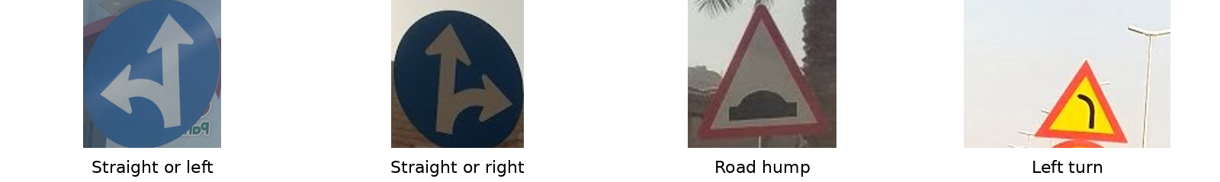
Representative ArTS samples from the released augmented test set [1].

2. BDD100K Road Object Detection
BDD100K provides 100,000 reference driving images at 1280 × 720 resolution, drawn from 40-second videos collected in the USA. The split is 70,000 train, 10,000 validation and 20,000 test images. Its 10 detection classes have bounding boxes and occlusion/truncation attributes; scenes vary by weather, location and time of day [3].
Class | Instances | Class | Instances
Pedestrian | 129,262 | Train | 179
Rider | 6,461 | Motorcycle | 4,296
Car | 1,021,857 | Bicycle | 10,229
Truck | 42,963 | Traffic light | 265,906
Bus | 16,505 | Traffic sign | 343,777
Published category totals from [3], Fig. 3; these are object instances, not image or training-only counts. One image may contain several objects.
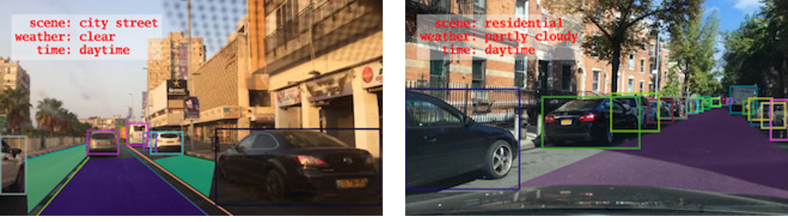
Representative city and residential scenes with object boxes, reproduced from [3], Fig. 1.

Official sources and release papers
[1] Latif et al. ArTS, Mendeley Data, v1 (2020). data.mendeley.com/datasets/4tznkn45mx/1
[2] Alghmgham et al. “Autonomous Traffic Sign (ATSR) Detection and Recognition using Deep CNN.” Procedia Computer Science 163 (2019), 266–274. doi:10.1016/j.procs.2019.12.108
[3] Yu et al. “BDD100K: A Diverse Driving Dataset for Heterogeneous Multitask Learning.” CVPR 2020. arxiv.org/abs/1805.04687 | Official source: bdd-data.berkeley.edu / github.com/bdd100k/bdd100k

